**REG- 16BIT0453**

**NAME- KRISHNA KUMAR MAHTO**

**EXP-1**

1. **Terminal command and output:**

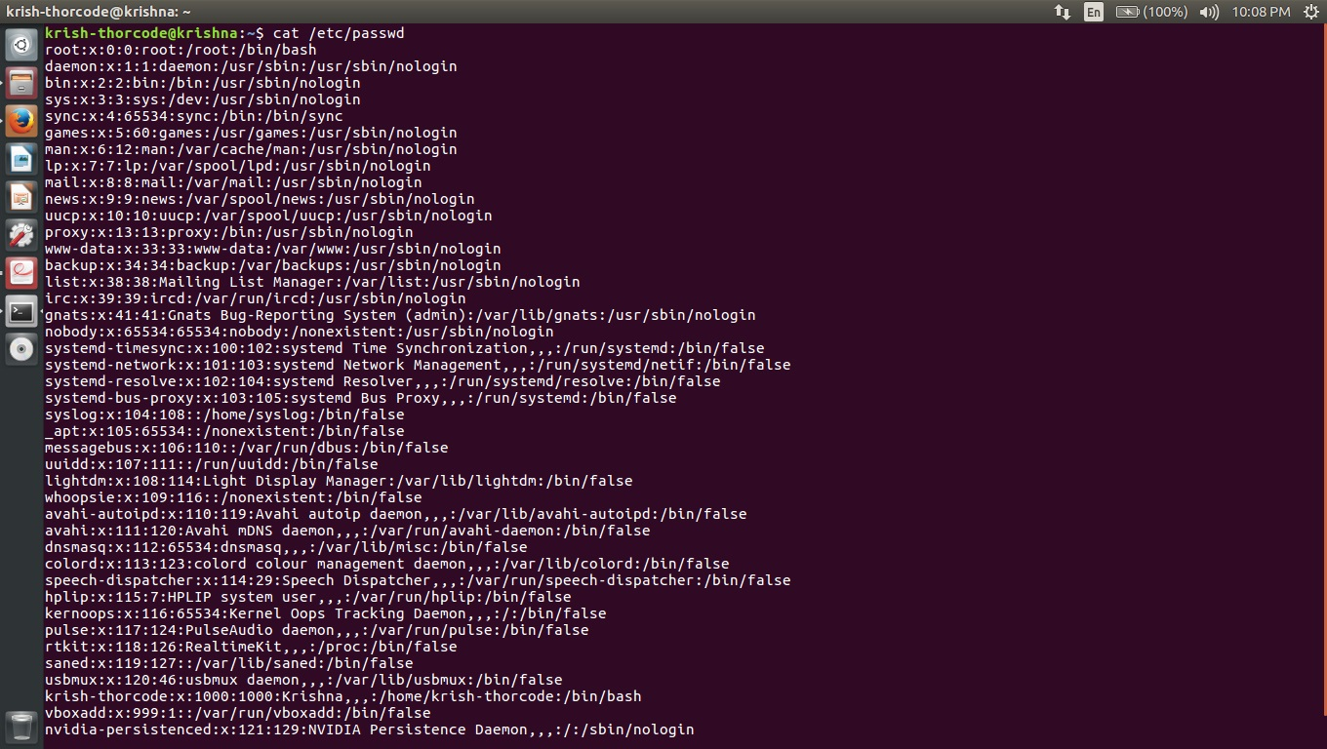

**Script code:**

echo “Enter filename“

read filename

echo “Enter word”

read word

echo “Number of occurences:”

grep -cow "$word" "$filename"

**OUTPUT:**

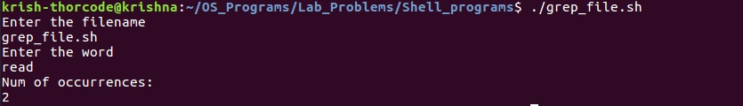

1. **CODE:**

echo "Enter a file name:"

read f

if [ -f $f ]

then

echo "File"

elif [ -d $f ]

then

echo "Directory"

else

echo "Invalid input"

fi

**OUTPUT:**

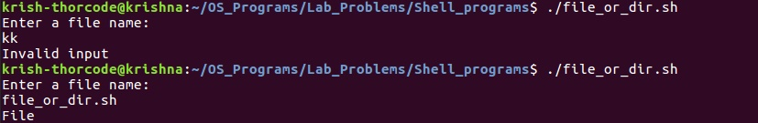

1. **CODE:**

echo -e "enter the user name :\c"

read usr

tuser=`who | tr -s " " | head -1 | cut -d " " -f1`

if [ "$tuser" = "$usr" ]

then

tm=`who | tr -s " " | head -1 | cut -d " " -f4`

uhr=`echo $tm | cut -d ":" -f1`

umin=`echo $tm | cut -d ":" -f2`

shr=`date "+%H"`

smin=`date "+%M"`

if [ $smin -lt $umin ]

then

shr=`expr $shr - 1`

smin=`expr $smin + 60`

fi

h=`expr $shr - $uhr`

m=`expr $smin - $umin`

echo "user name : $usr"

echo "login period : $h : $m"

else

echo "Invalid User"

fi

**OUTPUT:**



1. **CODE:**

while true

do

echo "*******MENU*********"

echo "

1. List of files.

2. Copying files.

3. Removing files.

4. Renaming files.

5. Linking files.

press [CTRL+C] TO EXIT"

echo "enter your choice "

read ch

case "$ch" in

1 ) echo "The list of file names."

ls

-

l || echo "These are file";;

2) echo "Enter the old filename."

read ofile

echo "Enter the new file name."

read nfile

cp $ofile $nfile && echo "Copied sucessfully." || echo "Copied is not possible." ;;

3 ) echo "Enter the file name to remove."

read rfile

rm

-

f $rf

ile && echo "Successfully removed." ;;

4 ) echo "Enter the old file name."

read ofile

echo "Enter the new file name."

read nfile

mv $ofile $nfile && echo "The file $ofile name re

named to $nfile." || echo "You

cann't Rename the file.".;;

5 ) echo "Enter the original filename."

read ofile

echo "Enter the new filename to link a file."

read lfile

ln $ofile $l

file && echo "Creat the linking file Sccessfully." || echo "You cann't Linking the file.";; * )

echo "Invalid option."

Echo " Enter correct choice."

esac

done

**OUTPUT:**

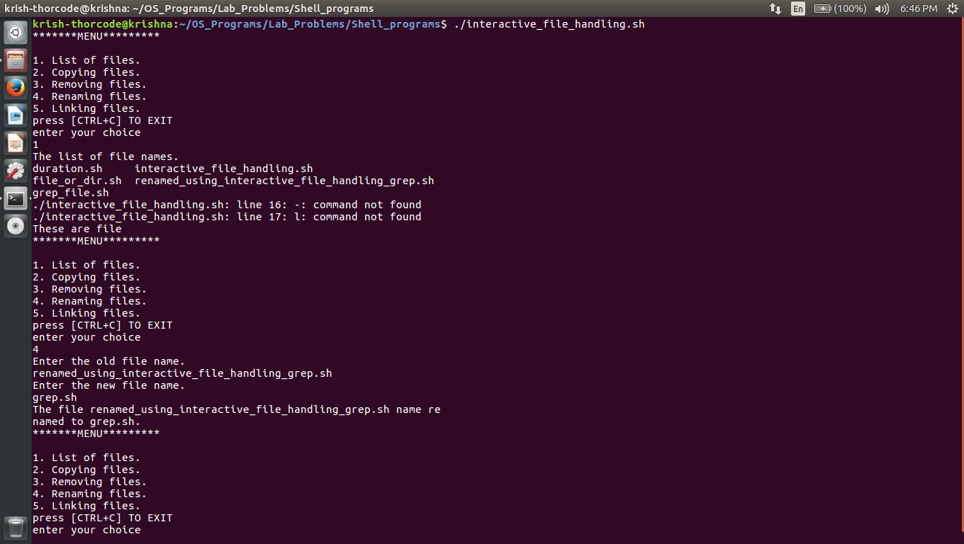

1. **CODE:**

echo "enter the directory name"

read dir

if [ -d $dir ]

then

cd $dir

ls > f

exec < f

while read line

do

if [ -f $line ]

then

if [ -r $line -a -w $line -a -x $line ]

then

echo "$line has all permissions"

else

echo "files not having all permissions"

fi

fi

done

fi

**OUTPUT:**

